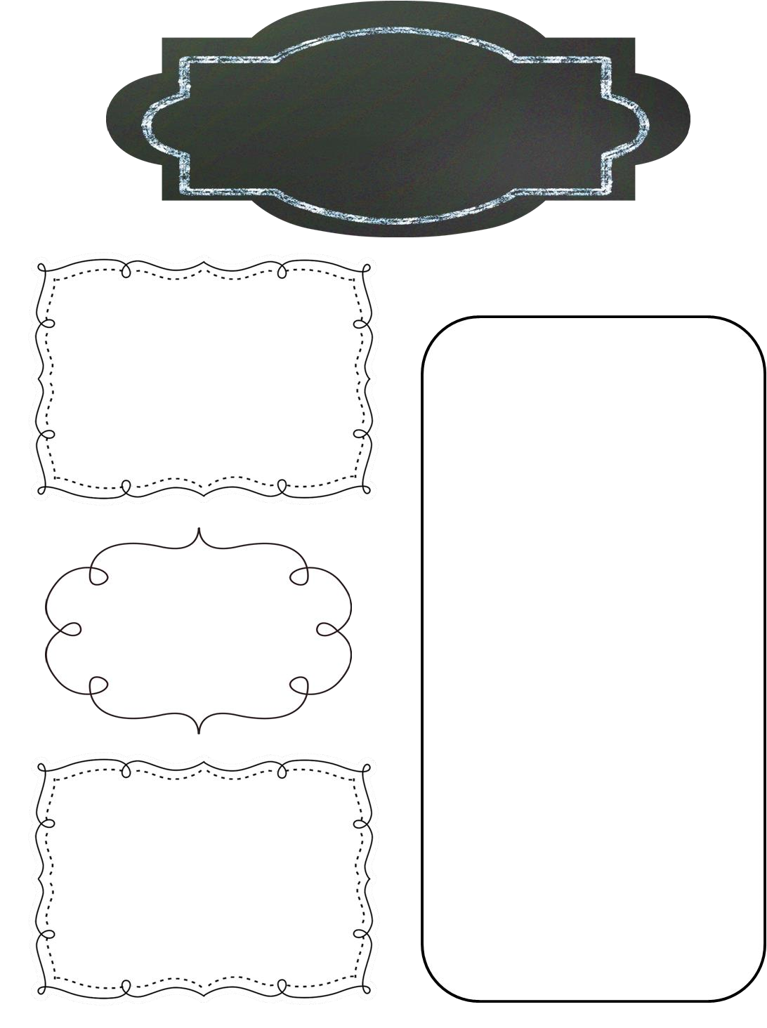

December Newsletter

Preschool Room

Reminders

With the weather getting colder please remember to dress your child accordingly. We will be going out when it is as low as 32 degrees windchill. Hats, gloves and heavy coats will all be used.

**Upcoming Events**

A Look Ahead

**Themes:**

Dec 3rd-7th: Twas the Night Before Christmas

Dec 10th-14th: Winter

Dec 17th-21st: Christmas

**The Details:**

* Date Day - Enjoy some Christmas shopping sans kids or take a nap! $30 for your first child, $15 per additional child
* We have a small part in Kindergarten Readiness’ Christmas Program! Each child should wear pajamas and be dropped off in the preschool classroom by 5:45pm. The program begins at 6pm. Refreshments will follow the program.
* Pajama/Movie Day- December 21 is a special day here at UCD!  Children are encouraged to wear their pajamas, bring their favorite snuggle buddy, and spend a day relaxing with their friends while we watch Christmas cartoons!  
    
  ​The Preschool room will also be doing a book exchange on this day.  If you would like your child to participate, please send a wrapped, gender-neutral book with them to school.  **(To: A friend)**

Dec 13th- Cosmo’s 3rd

Dec 1        Date Day: 12-4p  
Dec 4        Santa Visits! 10a  
Dec 7        Christmas Program 6p  
Dec 14        Date Night: 5:30-7:30p  
Dec 21        Pajama Day! Final day before Christmas Break  
Dec 24-Jan 1    UCD CLOSED

