Jan 1st-Miss Brianna

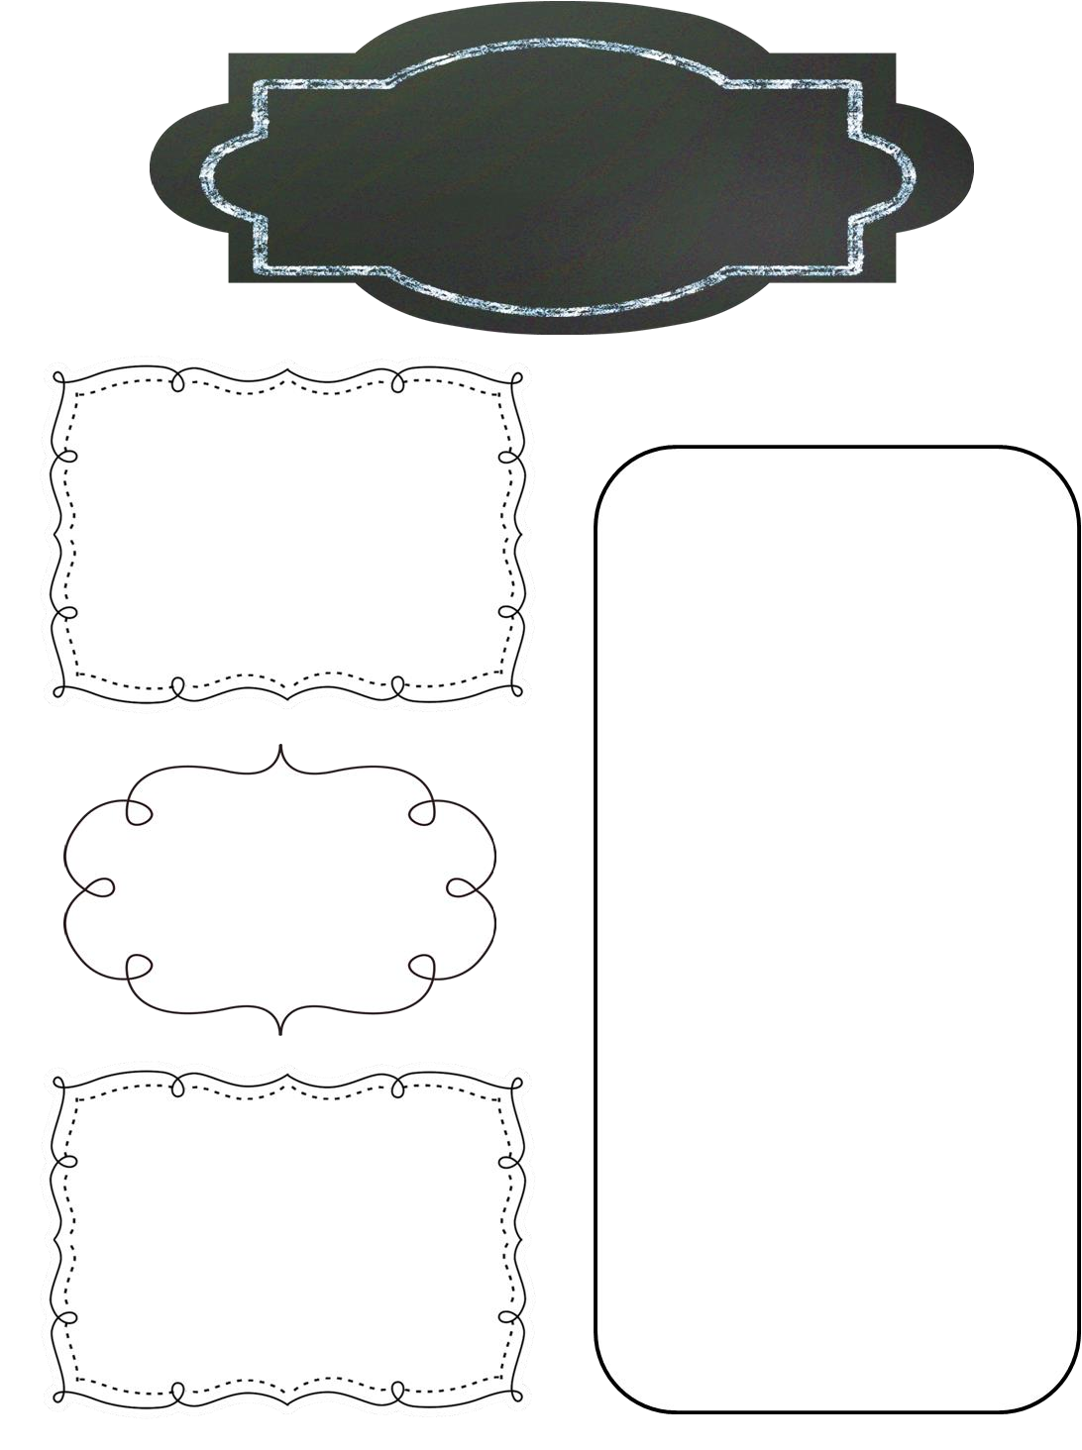

January Newsletter

Preschool Room

**Reminders**

Jan 1st: UCD Closed

Jan 2nd: Welcome Back!

Jan 21st: UCD Closed for Martin Luther King, Jr Day

**Upcoming Events**

Welcome back! I hope everyone had a great break! I cannot wait to hear all about it from your kiddos! Just a few things to remember:

* Weather: January is notoriously cold in Kansas, but there may days here and there where we will still be going outside for recess.  Unless the temperature dips below 32 degrees **(including wind chill)** we are required by law to take the children outside for at least 30 minutes in the morning and 30 in the afternoon.  It is a good idea for children to have not only their coats, but whatever layers you feel would be appropriate ***(i.e. hats, gloves, scarves, etc.)***
* Please make sure your child has **two complete sets** of clothes in their cubby/basket at all times **(2 shirts, 2 pants, 2 underwear, 2 socks)**.
* Please take home your child’s **bedding, water bottle,**and**hand towels** every Friday and **bring back** clean on Monday.

**Themes:**

Dec 31st-Jan 4th: Things That Go!

Jan 7th-11th: Friendship

Jan 14th-18th: Dinosaurs

Jan 21st-25th: Diversity

Jan 28th-Feb 1st- Kansas

