November Infant Newsletter
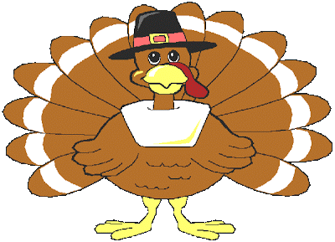
Themes:
November 5th-9th: Scarecrows/Birds
November 12th-16th: Testing
November 19th-23rd: Thanksgiving
November 26th-30th: Manners

Important Dates:
November 20th: Thanksgiving Luncheon 11:00am-1:00pm
November 22nd-23rd: CLOSED
November 27th: Board Meeting at 5:30pm
November 30th: Date Night at 5:30pm

Laundry Schedule:
November: Renyer
December: Wiard
January: Trumble

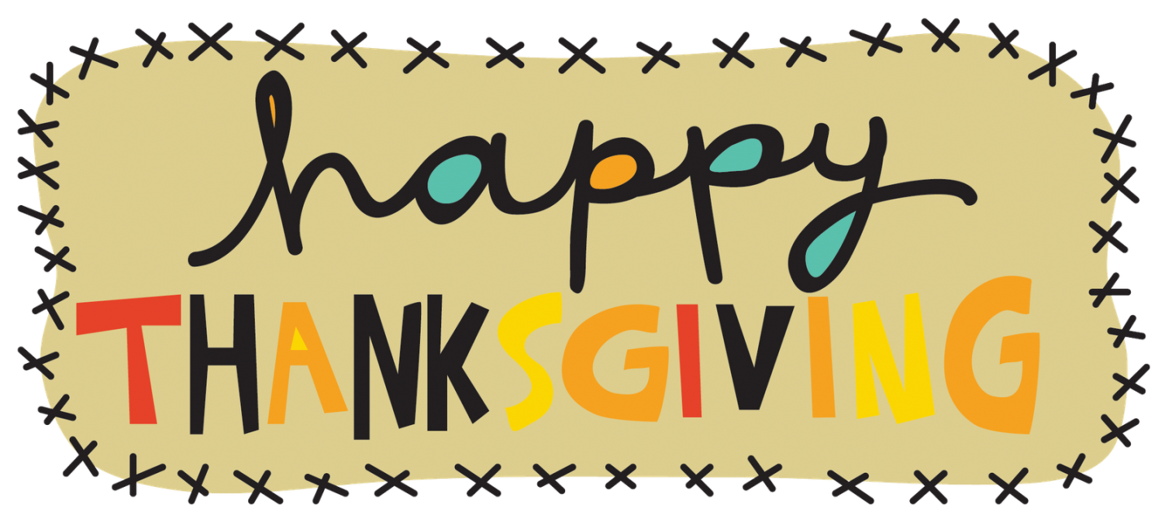
*Please RSVP to the office by November 14th with how many will be joining us for the Thanksgiving Lunch on November 20th.

