12:30p

June 3rd-7th: Zoo Animals

June 10th-14th: Farm Animals

June 17th-21st: Summer Fun

June 24th-28th: Ocean

July 1st-5th: Stars and Stripes

July 8th-12th: Safety

July 15th-19th: Opposites

July 22nd-26th:

July 29th-Aug 2nd: Picnic

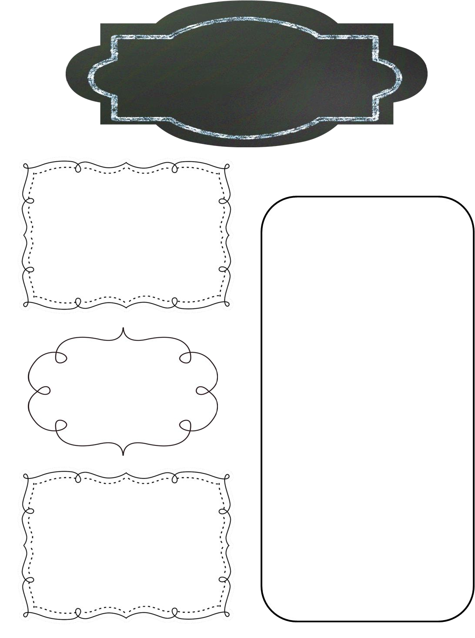

Summer Newsletter

Preschool Room

Reminders

Splash Days:

Every Monday and Friday

Monday June 17th: Donuts with Dads

Wednesday June 19th: Field Trip to Dandelions Arts and Crafts at 10am

June 22nd: Picnic in the Park 10:30-12:30

July 4th-5th: CLOSED

**Upcoming Events**

Please make sure your child always has **two complete sets** of clothes in their cubby/basket **(2 shirts, 2 pants, 2 underwear, 2 socks)**.

* Please take home your child’s **bedding, water bottle,**and **hand towels** every Friday and **bring back** clean on Monday.
* ***Splash day***- Splash day will be every Monday and Friday and will require a swimsuit, flip flops/water shoes, sunscreen and towel in a SEPARATE bag. *(Please make sure all your child’s belongings are marked with their name to avoid mix-ups!)*
* ***Field Trip -***We will be taking our field trip to Dandelions Arts and Crafts on Wednesday the 19th. We will leave the school around 9:45. We are encouraging as much parent involvement on this trip as possible as it’s a very hands on activity.
* **YOU’RE INVITED!** Your child and their family are invited to play at Boswell Park (1300 SW Jewell) on Saturday, June 22. Come play in the morning (around 10:30a) and then have a potluck picnic lunch around 11:30a. PTO will provide hot dogs, turkey dogs, and hamburgers. Toddler families should bring a dessert! Please bring your own water bottles or beverages.

Splash Days:

Please have your child dressed in their swimsuit, water shoes and Little Swimmers (if potty training). Your child will also need a towel.